**WIRELESS GESTURE CONTROL WHEEL CHAIR**

**A Report submitted**

**In partial fulfillment for the Degree of**

**Bachelors of Science**

**In**

**Information Science and Telecommunication**

By

**Abhishek Pradhan (19DIS096)**

**Rohit Kumar Sharma (19DIS126)**

**Smrutishree Sharma (19DIS091)**

**Soumya Ranjan Sahoo (19DIS092)**

**Tarinee Batsal Pattanaik (19DIS120)**

**Somya Ranjan Mohanty (19DIS104)**

**Under the guidance of**

**Mr. Shakti Prasad Dash**



**Ravenshaw University,Cuttack**

**Session 2019-22**

**Declaration**

We do here by declare that the dissertation titled **“Hand Gesture Control Wheel Chair”** submitted to **Ravenshaw University** in a particular fulfillment of degree of Bachelor in Science in **Information Science and Telecommunication**, is original research work done by us and the same has not been submitted either in part of full for the award of degree to any other university or sent for publication to any journal or book.

**CERTIFICATE**

This is to certify that the Project report entitled “Hand Gesture Control Wheel Chair “submitted by **Abhishek Pradhan (19DIS096), Smrutishree Sharma (19DIS096), Rohit Kumar Sharma (19DIS126), Soumya Ranjan Sahoo (19DIS92), Tarinee Batsal Pattanaik (19DIS120) and Somya Ranjan Mohanty (19DIS104)** under the guidance of **Mr. Shakti Prasad Dash**.

**Internal Guide Coordinator**

**Date External Examiner**

**DECLARATION**

We declare that this project report titled “Hand Gesture Control Wheel Chair” submitted in partial fulfilment of the degree of B.sc in (Information Science and Telecommunication) is a record of original work carried out by us under the supervision of Prof. Shakti Prasad Dash Dept. of Information Science and Telecommunication, Ravenshaw University, Cuttack.

Date Signature

Name of the Candidates

Rohit Kumar Sharma (19DIS126)

Abhishek Pradhan (19DIS096)

Smrutishree Sharma (19DIS091)

Soumya Ranjan Sahoo (19DIS092)

Tarinee Batsal Pattanaik (19DIS120)

Somya Ranjan Mohanty (19DIS104)

**ACKNOWLEDGEMENTS**

All acknowledgements to be included here. Please restrict to two pages. The name of the candidates shall appear at the end, without signature.

We take this opportunity to thank Mr. Shakti Prasad Dash who helped in preparing the guidelines.

We extend our sincere thanks to Sir and Coordinator sir “Amiya kumar Kanungo” for providing us with all facility that was required.

Date Name of the candidates

Rohit kumar Sharma

Abhishek Pradhan

Soumya Ranjan Sahoo

Smrutishree Sharma

Somya Ranjan Mohanty

Tarinee Batsal Pattanaik

**Dept. of IST, Ravenshaw University**

|  |  |  |
| --- | --- | --- |
| SL NO | CONTENTS | PAGE NO |
| 1 | Abstract |  |
| 2 | Introduction to embedded system |  |
| 3 | Embedded system design cycle |  |
| 4 | Project block diagram |  |
| 5 | Hardware requirements |  |
| 6 | Arduino |  |
| 7 | 3-axis accelerometer |  |
| 8 | 433 MHz Receiver and Transmitter |  |
| 9 | HT12E Encoder |  |
| 10 | HT12D Decoder |  |
| 11 | 7805 Transistor |  |
| 12 | L293D Motor Driver IC |  |
| 13 | Geared Motor |  |
| 14 | Node MCU ESP 8266 |  |
| 15 | 2 Way Switches |  |
| 16 | LED |  |
| 17 | 9V Battery |  |
| 18 | 3.5V Battery |  |
| 19 | 750k Resistor |  |
| 20 | 33k Resistor |  |
| 21 |  |  |
| 22 |  |  |
| 23 |  |  |
| 24 |  |  |
| 25 |  |  |
| 26 |  |  |
| 27 |  |  |
| 28 |  |  |
| 29 |  |  |

**Abstract**

The aim of this paper is to prepare a Hand Gesture Controlled Wheelchair for the physically disabled people who face difficulty in moving from one place to another in day today life. These days joystick controlled wheel chair is available in the market whose cost range between Rs 80,000 to Rs 1,50,000. We have prepared this Hand Gesture Controlled Wheelchair in Rs 15,000. An accelerometer is used as a sensor which gives an analog signal on its movement in any of the 6 axis directions that is positive X axis, negative X axis, positive Y axis, negative Y axis, positive Z axis, negative Z axis. In this project we have considered X and Y axis for the direction. Further the input from sensor is given to encoder which sends the data wirelessly through the transmitter, then the data is received at the receiver end and the sensor data is decoded and finally given to microcontroller. Based on data received the from accelerometer the microcontroller sends the signal accordingly to relays to move the wheelchair in forward, backward, left, right directions. The accelerometer used here is MEMS (micro-electromechanical system).

**Introduction to Embedded System**

An Embedded System is a combination of computer hardware and software, and perhaps additional mechanical or other parts, designed to perform a specific function an embedded system is a microcontroller-based software driven, reliable, real-time control system, autonomous, or human or network interactive, operating on diverse physical variables and in diverse environments and sold into a competitive and cost-conscious market.

An embedded system is not a computer system that is used primarily for processing. not a software system on PC or IINIX, not a traditional business or scientific application. High-end embedded & lower end embedded systems High-end embedded system Generally 32: 64 Bit Controllers used with OS. Examples Personal Digital Assistant and Mobile phones etc. Loves end embedded systems - Generally 8,16 Bit Controllers used with a minimal operating systems and hardware layout designed for the specific purpose. Examples Small controllers and devices in our everyday life like Washing Machine, Microwave Ovens, where they are embedded in.

**System Design Calls:**

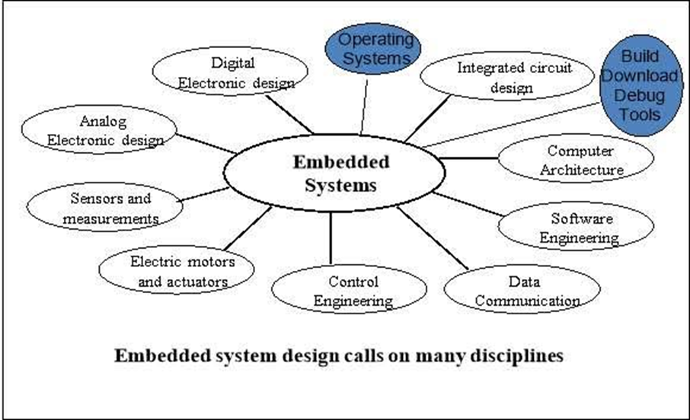

**PROJECT BLOCK DIAGRAM**

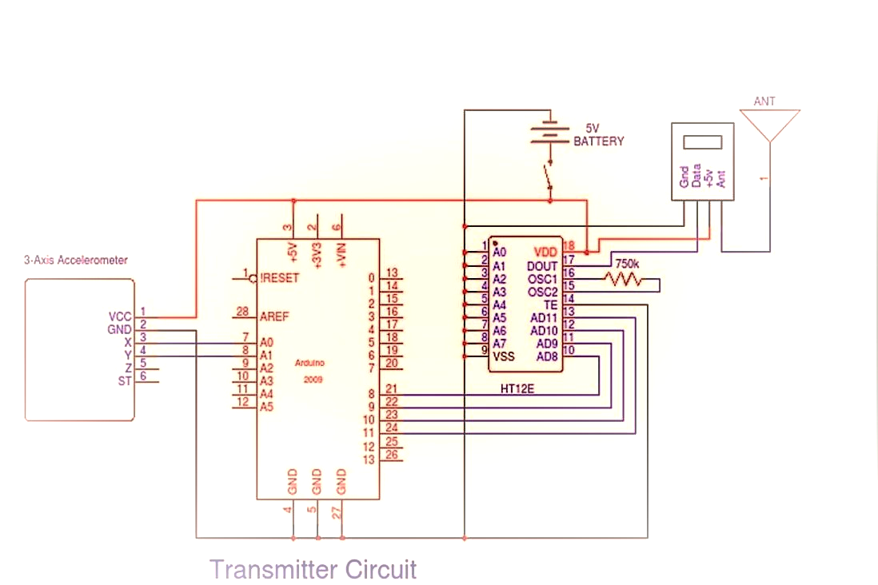

Here is the circuit diagram of trans-meter circuit of the wheelchair gesture embedded strap.

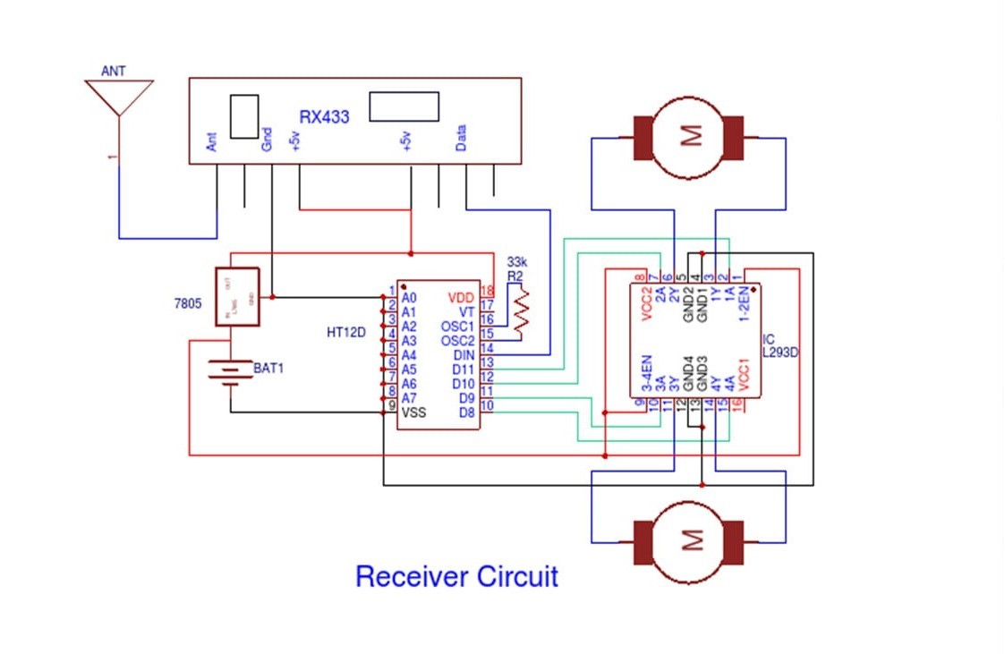

Here this diagram represents the receiver circuit of the wheel chair which will embedded to the wheelchair for gesture hand control.

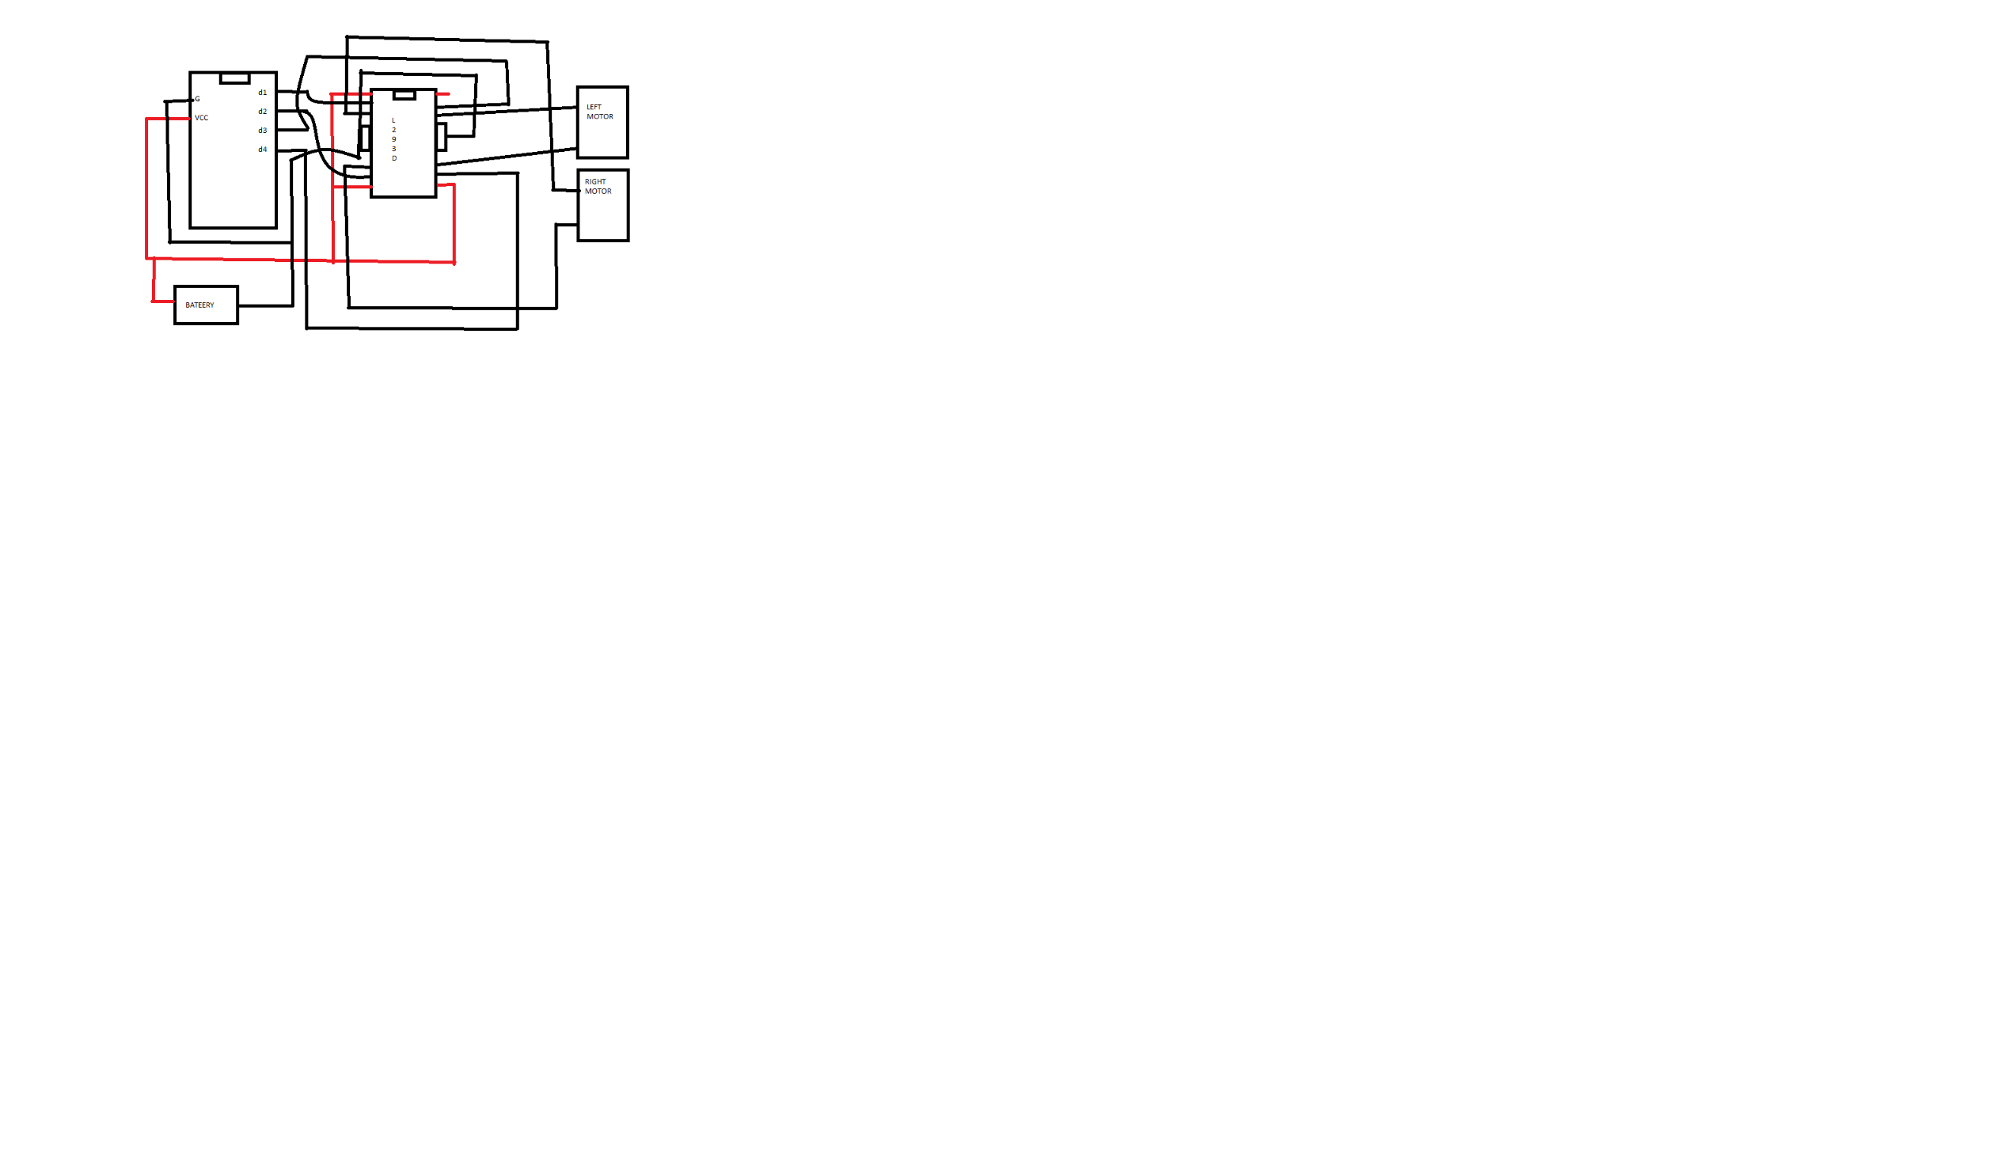

This is the block diagram of receiver circuit for mobile application for voice control.

**HARDWARE REQUIRMENTS**

Hardware Components:

1. Arduino

2. 3-axis accelerometer

3. 433MHz Receiver and Transmitter

4. HT12E Encoder

5. HT12D Decoder

6.7805 Transistor

7. L293D Motor Drive IC

8. Geared Motor

1. **ARDUINO:-**

* Arduino is an easy-to-use open platform to create electronics projects. Arduino boards play a vital role in creating different projects. It makes electronics accessible to non-engineers, hobbyists, etc.
* The various components present on the Arduino boards are**Microcontroller, Digital Input/output pins, USB Interface and Connector, Analog Pins, Reset Button, Power button, LED's, Crystal Oscillator**, and **Voltage Regulator**. Some components may differ depending on the type of board.
* The most standard and popular board used over time is **Arduino UNO**. The ATmega328 Microcontroller present on the UNO board makes it rather powerful than other boards. There are various types of Arduino boards used for different purposes and projects. The **Arduino** Boards are organized using the Arduino (IDE), which can run on various platforms. Here, IDE stands for Integrated Development Environment.

t..! TWIA 9-10-21

* **Arduino Nano**
* The Arduino Nano is a small Arduino board based on ATmega328P or ATmega628 Microcontroller. The connectivity is the same as the Arduino UNO board.
* The Nano board is defined as a sustainable, small, consistent, and flexible microcontroller board. It is small in size compared to the UNO board. The devices required to start our projects using the Arduino Nano board are Arduino IDE and mini USB.
* The Ardunio Nano includes an I/O pin set of 14 digital pins and 8 analog pins. It also includes 6 Power pins and 2 Reset pins.

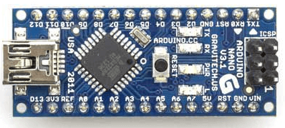

# 3-Axis Accelerometer

* A 3-axis accelerometer is used to calculate the pitch and roll of the drilling bit.
* The 3-axis accelerometer consists of three -5 to +5g accelerometers that are mounted on a block. It measures the three mutually orthogonal components of the acceleration of gravity for a stationary drill bit.
* The attitude information includes the pitch, roll, and azimuth of the drilling bit. By measuring the acceleration due to gravity, an accelerometer calculates the angle of tilt with respect to the earth and the velocity and direction of the drill bit.
* To compensate for errors, two redundant accelerometers fixed at two different planes are used.

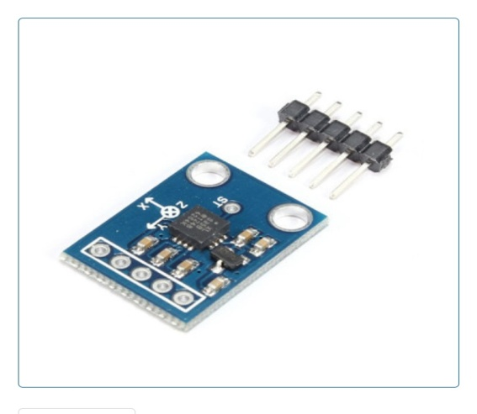

## Trenchlesspedia Explains 3-Axis Accelerometer

* The 3-axis accelerometer is used in conjunction with compatible software. Inertial guidance systems use fiber-optic gyroscopes along with highly sensitive accelerometers to locate the drill head precisely along the borepath.
* The connection of the optical gyro system from downhole to the surface is done via a transmission system that sends the pitch, roll and azimuth readings three times in a second providing the engineer with real-time measurements.
* The pitch and the azimuth should be determined during the drilling process to operate the drilling machine economically hence using the term measurement while drilling or MWD.
* The inertial guidance system is used for drilling head guidance in trenchless construction methods of vertical drilling and horizontal directional drilling (HDD) and relies on knowing the initial position, velocity, and attitude.

**433MHz Receiver and Transmitter**

The 433 MHz RF transmitter and receiver module is a pair of small RF (i.e. radio-frequency) electronic modules used to send and receive radio signals between any two devices. The transmitter module sends the data from the transmitter end and the Receiver module receives that data at the receiver’s end.

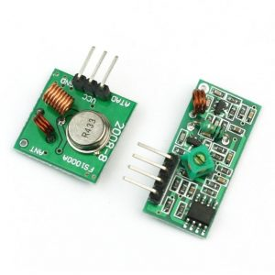

433 MHz RF transmitter and receiver

## ****433MHz RF Transmitter and Receiver Module Pinout:****

### Transmitter

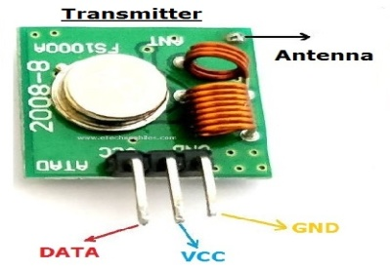

433 MHz transmitter module pinout

|  |  |
| --- | --- |
| PIN Name | Pin Description |
| **VCC** | Used to power the RF receiver module. |
| **GND** | Ground pin of the module. Connect it with the controllers and encoder/decoders GND pin. |
| **DATA** | This is the data pin of the transmitter. It takes the data from the microcontroller or encoder and broadcast it via the antenna. |
| **ANT** | The antenna pin is not necessary to use but it is recommended. The module can only operate max 3 meters without an antenna but its range can be extendable up to 100 meters by using a small hook up wire as an Antenna. |

### Reciever

### 433 MHz Receiver Module Pinout

433 MHz Receiver Module Pinout

|  |  |
| --- | --- |
| PIN Name | Pin Description |
| **VCC** | Used to power up the RF receiver module. Unlike the transmitter, the supply voltage of the receiver is 5v. |
| **GND** | Ground pin of the module. Connect it with the controllers and encoder/decoders GND pin. |
| **DATA** | These pins output the digital data received. The two center pins are internally connected, so we can use either one of them for data output. |
| **ANT** | The antenna pin is not necessary to use but is recommended. The module can only operate  up to 3 meters without an antenna but its range can be extended up to 100 meters by using a small hook-up wire as an Antenna |
|  |  |

**433MHz RF Transmitter Module Features:**

* The Transmitter offers only one-way communication through 433.92MHz frequency at 1Kb data rate
* It operates at a range of 3-12V which is also the power operating volts of most of the microcontrollers and boards.
* The module uses the ASK (Amplitude Shift Key) modulation method to transmits the data.
* It is one of the very low-cost power effective modules for both commercial, hobbyist, and developers.
* 433MHz Transmitter is one of the cheapest RF transmitters and it has a lot of applications and can be used interface with almost every microcontroller.

## ****433MHz RF Receiver Module Features:****

* The RF receiver delivers the output to the data pin in an encoded form.
* The operational voltage range of the module is 5V maximum.
* The frequency of the receiver can be changed using a node present on it.
* It is one of the popular and cheapest receivers and has low power consumption.
* 433MHz RF receiver module uses the ASK signal as an input.

**Specifications of 433MHz RF Transmitter Module: –**

* Max range with the antenna in normal Conditions: **100 Meters**
* RX Receiver Frequency: **433 MHz**
* RX Typical Sensitivity: **105 Dbm**
* RX Supply Current: **3.5 mA**
* RX IF Frequency: **1MHz**
* RX Operating Voltage: **5V**
* TX Frequency Range: **433.92 MHz**
* TX Supply Voltage: **3V ~ 6V**
* TX Output Power: **4 ~ 12 Dbm**

## ****Specifications of 433MHz RF Receiver Module:****

* Max range with the antenna in normal Conditions: **100 Meters**
* RX Receiver Frequency: **433 MHz**
* RX Typical Sensitivity: **105 Dbm**
* RX Supply Current: **3.5 mA**
* RX IF Frequency: **1MHz**
* RX Operating Voltage: **5V**

**HT12E Encoder**

[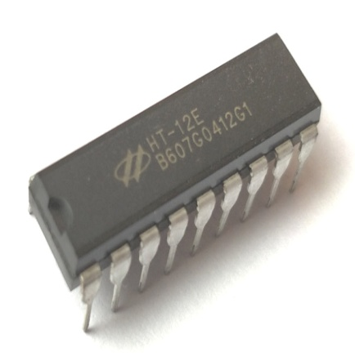](https://components101.com/sites/default/files/components/HT12E-Encoder-IC.jpg)[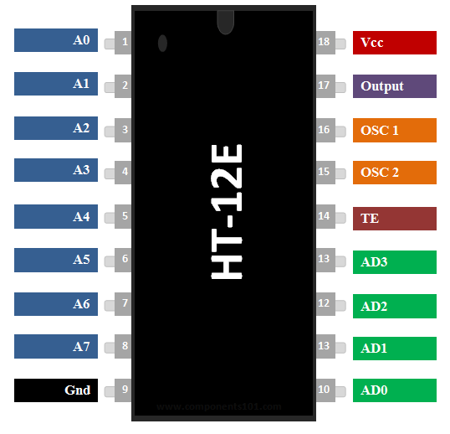](https://components101.com/sites/default/files/component_pin/HT12E-Pinout.png)

**HT12E RF Encoder IC** **HT12E Encoder IC Pin Diagram**

### ****HT12E Pin Configuration****

|  |  |  |
| --- | --- | --- |
| **Pin Number** | **Pin Name** | **Description** |
| **1 to 8** | A0,A1,A2,A3,A4,A5,A6 & A7 | These are the 8-bit address bits, which is used to protect your data. We should set the bits in same pattern on Encoder and Decoder IC to pair them. |
| **9** | Ground/Vss | Connected to the Ground of circuit |
| **10 to 13** | AD0, AD1, AD2 & AD3 | These four pins are used to send data, the data encoded here will be decoded on HT12D IC sharing the same address bits |
| **14** | Transmission Enable(TE) | This pin has to be connected to Ground (0V) to enable the Transmission. |
| **15 and 16** | Oscillator pins 1 & 2 | The IC has a built in oscillator. This oscillator can be used by connecting these two pins through a 1M Resistor |
| **17** | Output | The Encoded 12 bit output data can be obtained from this pin |
| **16** | Vcc/Vdd | This pin powers the IC, typically +5V is used. Can range from 2.4V to 12V |

### ****Features****

* + 12-bit Encoder IC to be used with [HT12D](https://components101.com/ht12d-rf-decoder-ic)
  + Encoded data has 4 Data bits and 8 Address bits (8+4=12-bits)
  + Commonly used for **RF and IR wireless transmission**
  + Wide supply voltage range from 2.4V to 12V, typically 5V is used
  + Low stand by current of 0.1uA at Vcc=5V
  + Available in 16-pin DIP, 20-pin SOP.

### ****Applications****

* Used to convert Parallel 4-bit data  to series data
  + - Highly useful in wireless communication projects involving RF or IR
    - Remote controlled systems like garage doors, Car alarm system, Car door controls, etc.
    - Can be used in Home automation for short range remote switching
    - Safety systems like Burglar alarm system, Smoke or Fire alarm system etc..

**HT12D Decoder**

[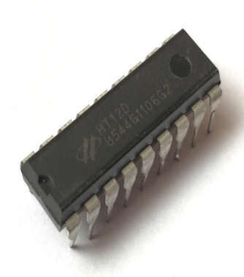](https://components101.com/sites/default/files/components/HT12D-IC.jpg)[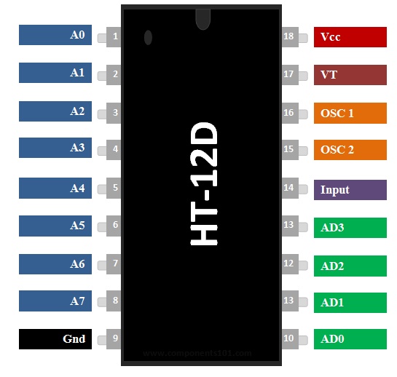](https://components101.com/sites/default/files/component_pin/HT12D-Pinout.png)

**HT12D RF Decoder IC** **HT12D RF Decoder IC Pinout**

### ****HT12D Pinout Configuration****

|  |  |  |
| --- | --- | --- |
| **Pin Number** | **Pin Name** | **Description** |
| **1 to 8** | A0,A1,A2,A3,A4,A5,A6 & A7 | These are the 8-bit address bits, which is used to protect your data. We should set the bits in same pattern on Encoder and Decoder IC to pair them. |
| **9** | Ground/Vss | Connected to the Ground of circuit |
| **10 to 13** | AD0, AD1, AD2 & AD3 | These four pins are used to obtain the data bits by decoding the data from HT12E IC |
| **14** | Input | The Encoded 12 bit output data obtained from HT12E has to be given here |
| **15 and 16** | Oscillator pins 1 & 2 | The IC has a built in oscillator. This oscillator can be used by connecting these two pins through a 1M Resistor |
| **17** | Valid Transmission (VT) | This pin will go high when a data is received. It is not mandatory to use it. |
| **16** | Vcc/Vdd | This pin powers the IC should use only 5V |

### ****Features****

* 12-bit Decoder IC to be used with HT12E
* Decoded data has 4 Data bits and 8 Address bits (8+4=12-bits)
* Commonly used for RF and IR wireless transmission
* Operating Voltage 5V
* Low stand by current of 0.1uA at Vcc=5V
* Available in 16-pin DIP, 20-pin SOP

### ****Applications****

* Used to convert Parallel 4-bit data  to series data
* Highly useful in wireless communication projects involving RF or IR
* Remote controlled systems like garage doors, Car alarm system, Car door controls etc.
* Can be used in Home automation for short range remote switching
* Safety systems like Burglar alarm system, Smoke or Fire alarm system etc..

**7805 Transistor**

7805 datasheet which is the popular 5V voltage regulator IC and the 7805 pinout.It is designed to provide a constant 5V at 1.5A max when powered by 7.3V to 35V.We usually use it as a stable voltage source for a common digital circuit. Sometimes, the power supply using a transformer can have too high a voltage.We should help lower the voltage by using The 7805, it can reduce and keep the constant voltage at 5V. Therefore, It is good for powering the TTL family of digital integrated circuits.

#### Basic Features

* **Typical output voltage:** A typical **7805** delivers 5V. Some model may provide from 4.8V to 5.2V.
* **Load regulation:** The load is typically regulated to within 10mV and less than 50mV.
* **Peak output current:** The TO220 version of 7805 delivers 1A with a normal heatsink, but it could deliver up to 1.5A by mounting it to an appropriate heatsink.
* **Internal overload and Short circuit current** **protection:** If the **7805 regulator IC** operates over too much and starts to overheat. A special thermal overload circuit will automatically turn off the chip until the temperature returns to a safe level.
* **The minimum input voltage to deliver 5 volts output:**7.3V. below 7.3V the chip may not provide a stable 5 volts.
* **The operating current (IQ) is 5mA**.
* Junction Temperature maximum 125 degrees Celsius.
* Available in TO-220 and KTE package.
* **Maximum input voltage:** 30VDC, but at higher voltage, it needs to hold current and more power on itself. Therefore, it will become too hot.

### 7805 Pinout and Specifications

[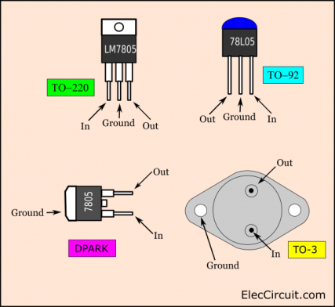](https://www.eleccircuit.com/wp-content/uploads/2017/05/LM7805-pinout.png)

**7805 pinout**

The 7805 has many components inside it, that are connected as the schematic diagram below. It is so many! In general use, we do not need to understand those components. We just by understanding its features and limitations to use it on a normal basis.

[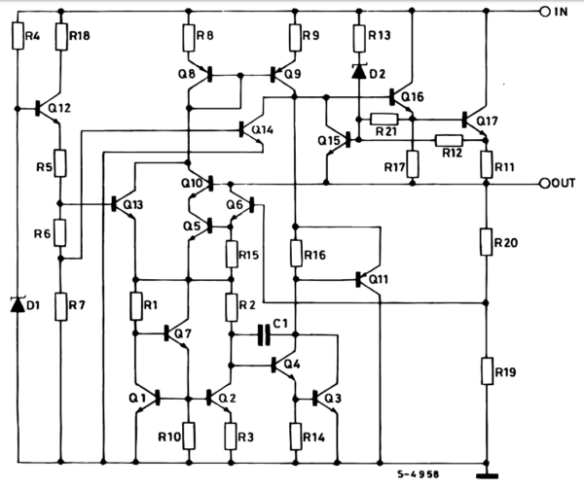](https://www.eleccircuit.com/wp-content/uploads/2017/05/7805-Schematic-diagram-inside.png)

**View 7805 datasheet: Schematic diagram inside**

Compare to the simplest Zener diode and transistor regulator circuit with an input voltage of 12V and constant output voltage of 5V at 1A.

[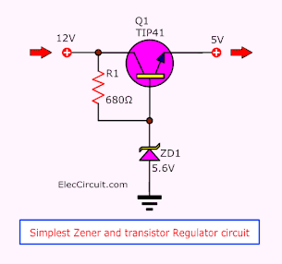](https://www.eleccircuit.com/eleccircuit-book-v-02/)

**L293D Motor Drive IC**

[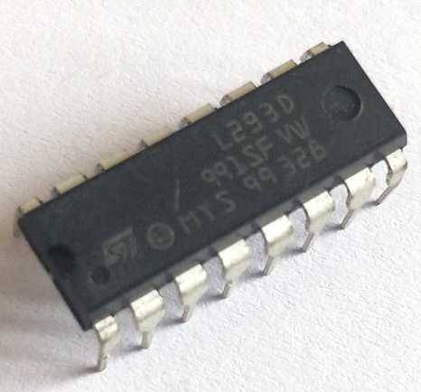](https://components101.com/sites/default/files/components/L293D.jpg)[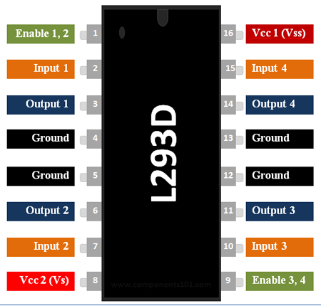](https://components101.com/sites/default/files/component_pin/L293D-Pinout.png)

**L293D Motor Driver IC** **Motor Driver IC L293D Pinout**

### ****L293D Pin Configuration****

|  |  |  |
| --- | --- | --- |
| **Pin Number** | **Pin Name** | **Description** |
| **1** | Enable 1,2 | This pin enables the input pin Input 1(2) and Input 2(7) |
| **2** | Input 1 | Directly controls the Output 1 pin. Controlled by digital circuits |
| **3** | Output 1 | Connected to one end of  Motor 1 |
| **4** | Ground | Ground pins are connected to ground of circuit (0V) |
| **5** | Ground | Ground pins are connected to ground of circuit (0V) |
| **6** | Output 2 | Connected to another end of  Motor 1 |
| **7** | Input 2 | Directly controls the Output 2 pin. Controlled by digital circuits |
| **8** | Vcc2 (Vs) | Connected to Voltage pin for running motors (4.5V to 36V) |
| **9** | Enable 3,4 | This pin enables the input pin Input 3(10) and Input 4(15) |
| **10** | Input 3 | Directly controls the Output 3 pin. Controlled by digital circuits |
| **11** | Output 3 | Connected to one end of Motor 2 |
| **12** | Ground | Ground pins are connected to ground of circuit (0V) |
| **13** | Ground | Ground pins are connected to ground of circuit (0V) |
| **14** | Output 4 | Connected to another end of Motor 2 |
| **15** | Input 4 | Directly controls the Output 4 pin. Controlled by digital circuits |
| **16** | Vcc2 (Vss) | Connected to +5V to enable IC function |

### ****Features****

* Can be used to run Two DC motors with the same IC.
* Speed and Direction control is possible
* Motor voltage Vcc2 (Vs): 4.5V to 36V
* Maximum Peak motor current: 1.2A
* Maximum Continuous Motor Current: 600mA
* Supply Voltage to Vcc1(vss): 4.5V to 7V
* Transition time: 300ns (at 5Vand 24V)
* Automatic Thermal shutdown is available
* Available in 16-pin DIP, TSSOP, SOIC packages

### ****Applications****

* Used to drive high current Motors using Digital Circuits
* Can be used to drive [Stepper motors](https://components101.com/motors/28byj-48-stepper-motor)
* High current LED’s can be driven
* [Relay](https://components101.com/5v-relay-pinout-working-datasheet) Driver module (Latching Relay is possible)

**Geared Motor**

A gearmotor, also called a gear motor or a geared motor, is a combination of a gear system or gearbox and an electric motor. When asking yourself “what is a gear motor” or “what a geared motor is,” you are actually probably wondering how a gearmotor can be useful for your company's products or production facility. Geared motors are efficient because you will only have to mount and operate one system, instead of several. Sometimes inaccurately called “gears motors,” or even geared motors, gearmotors generally combine an efficient motor, such as an Electrically Commutated Motor, with a gear reducer or gearhead. These motor gear combinations are a great way to minimize alignment issues with your motor and its gearbox. You don't need to be worried about separately sourcing gears for motors; instead, you can work with a motor and gear in one: a gear drive motor.

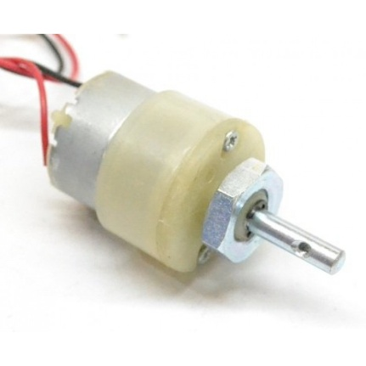

**Advantages:-**

* The hand gesture wheelchair has the ability to bridge the gap between man and machine.
* Further this hand gesture can be changed to speech and brain signal recognition which will be a battle winning factor for all those people whose whole body is paralyzed.
* We can further improve wheelchairs by making it with low cost and high accuracy which are operating by a wireless remote with various different sensors.
* Output of various different purpose sensors can be applied to high frequency and accurate wireless transmitter circuit and can received at wheelchair circuit by receiver circuitry. So that harmonics can be reduced and system becomes more robust and lossless

**CONCLUSION**

The wheelchair is fully capable of carrying the load up to 110Kg, and moving in accordance to the gesture given by the person who is using the wheel chair. Certain improvisation and improvement can be done to make the wheelchair more reachable to those whose whole body is paralyzed. Certain eyes gesture or brain signals reader can be imparted on the wheelchair system so as to make it better.

**REFERENCES**

[1] Prof. Vishal V. Pande, ”Hand Gesture Based Wheelchair Movement Control for Disabled Person Using MEMS” et al Int. Journal of Engineering Research and Applications Vol. 4, Issue 4( Version 4), April 2014, pp.152-158

[2] Amundson JS, Amundson SG,“A joystick controlled wheelchair”,Biomed Sci Instrum .1991; 27:131-3.

[3] [http://censusindia.gov.in/Census_And_You/disabled_p opulation.aspx](http://censusindia.gov.in/Census_And_You/disabled_p%20opulation.aspx)

[4] [www.languageinindia.com/jan2014/disabilityinindia201 1data.pdf](http://www.languageinindia.com/jan2014/disabilityinindia201%201data.pdf))

[5] Mahaboob Ali Shaik M.Prathyusha, K. S. Roy, “Voice and touch screen based direction and speed control sof wheel chair for physically challenged using arduino